**SQL Query Output**

# 1.To select the name and email of all users who have placed an order:

SELECT Users.name, Users.email

FROM Users

JOIN Orders ON Users.user_id = Orders.user_id;

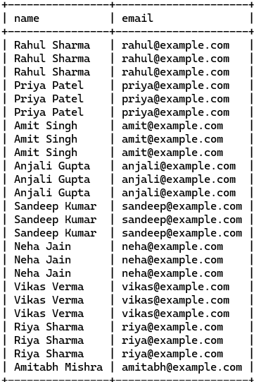

# 2.To select the name and address of all restaurants that have received a rating of 4 or higher:

SELECT Restaurants.name, Restaurants.address

FROM Restaurants

JOIN Rating ON Restaurants.restaurant_id = Rating.restaurant_id

WHERE Rating.rating >= 4;

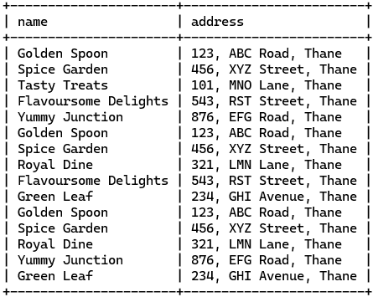

# 3.To select the order id, total, and status of all orders that have been placed by a user with the email ‘rahul@example.com’:

SELECT Order_id, Order_total, delivery_status

FROM Orders

JOIN Users ON Orders.user_id = Users.user_id

WHERE Users.email = 'rahul@example.com';

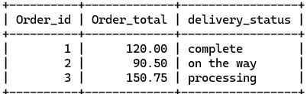

# 4.To select the name, phone, and rating of all drivers who have delivered an order:

SELECT Drivers.email, Drivers.phone, Rating.rating

FROM Drivers

JOIN Orders ON Drivers.driver_id = Orders.driver_id

JOIN Rating ON Orders.order_id = Rating.rating_id;

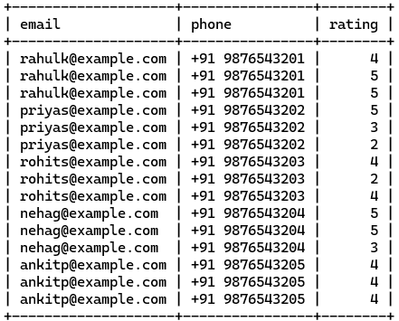

# 5.To select the name, price and status of the payment of all menu items on a particular restaurant:

SELECT Menu.item_name, Menu.price, Payment.status

FROM Menu

JOIN Orders ON Menu.restaurant_id = Orders.restaurant_id

JOIN Payment ON Orders.order_id = Payment.order_id

WHERE Menu.restaurant_id = 1;

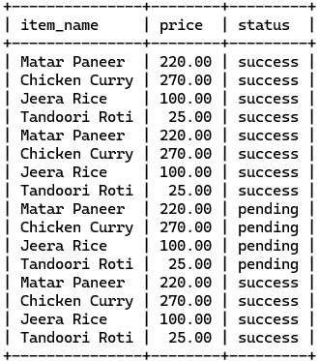

# 6.To select all the addresses of the user who placed a particular order:

SELECT Address.street, Address.city, Address.state, Address.pincode

FROM Address

JOIN Orders ON Address.user_id = Orders.user_id

WHERE Orders.order_id = 4;

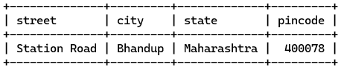

# multiple join and groupby & Having clause

# 1. To select the average rating for each restaurant, along with the number of ratings they have received:

SELECT Restaurants.name, AVG(Rating.rating) as avg_rating, COUNT(Rating.rating) as rating_count

FROM Restaurants

JOIN Rating ON Restaurants.restaurant_id = Rating.restaurant_id

GROUP BY Restaurants.name;

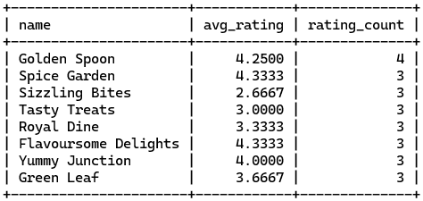

# Groupby clause

# Get the total number of orders per restaurant with order total greater than 50:

SELECT restaurant_id, COUNT(*) AS total_orders

FROM Orders

GROUP BY restaurant_id

HAVING SUM(order_total) > 100;

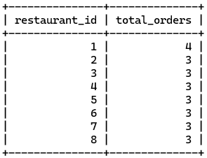

# Where Clause

# Get orders with delivery status 'Delivered' and placed by user with ID 5:

SELECT * FROM Orders

WHERE delivery_status = 'Complete' AND user_id = 5;

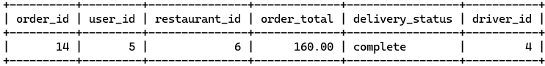

# Get drivers located in 'Vartak Nagar':

SELECT * FROM Drivers

WHERE location = 'Vartak Nagar, Thane';



# Entries with GROUP BY Clause:

# Get the average rating for each restaurant:

SELECT restaurant_id, AVG(rating) AS average_rating

FROM Rating

GROUP BY restaurant_id;

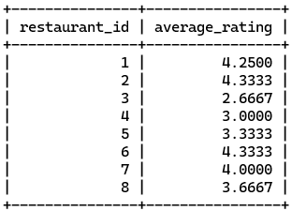

# Get the count of orders for each payment status:

SELECT status, COUNT(*) AS order_count

FROM Payment

GROUP BY status;

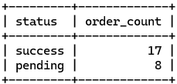

# Single Sub Query

# Get the total number of orders for users who have placed more than 2 orders:

SELECT COUNT(*) AS total_orders

FROM Orders

WHERE user_id IN (SELECT user_id

FROM Orders

GROUP BY user_id

HAVING COUNT(*) > 2);

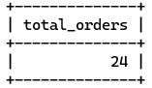

# Get the names of users who have placed orders with a total greater than 150:

SELECT name FROM Users

WHERE user_id IN (

SELECT user_id

FROM Orders

WHERE order_total > 150);

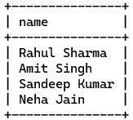

# Get the average rating of restaurants that have received ratings:

SELECT AVG(rating) AS average_rating

FROM Rating

WHERE restaurant_id IN (

SELECT DISTINCT restaurant_id

FROM Rating);

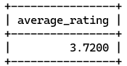

# Get the names of users who have not placed any orders:

SELECT name FROM Users

WHERE user_id NOT IN (

SELECT DISTINCT user_id

FROM Orders);

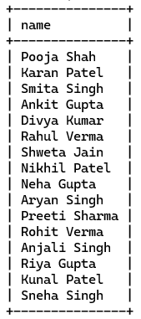

# Double Subqueries:

# Identify users who have ordered from restaurants that are serviced by drivers operating from 'Kolshet, Thane'.

SELECT name FROM Users

WHERE user_id IN (

SELECT user_id

FROM Orders

WHERE restaurant_id IN (

SELECT driver_id

FROM Drivers

WHERE location = 'Kolshet, Thane'));

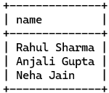

# Get the total number of orders placed at restaurants where the average rating is above 4:

SELECT COUNT(*) AS total_orders

FROM Orders

WHERE restaurant_id IN (

SELECT restaurant_id

FROM Rating

GROUP BY restaurant_id

HAVING AVG(rating) > 4);

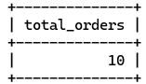

# Get the names of users who have placed orders with a total greater than the average order total:

SELECT name

FROM Users

WHERE user_id IN (

SELECT user_id

FROM Orders

WHERE order_total > (

SELECT AVG(order_total)

FROM Orders));



# Like Operator:

# Get users whose email contains 'gmail':

SELECT * FROM Users WHERE email LIKE '%example%'

limit 5;

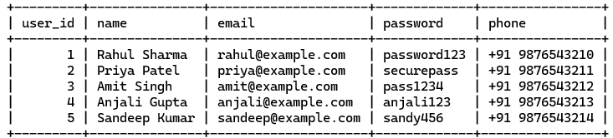

# Having Clause:

# Get the total order amount for each user who has placed orders more than 200:

SELECT user_id, SUM(order_total) AS total_amount

FROM Orders

GROUP BY user_id

HAVING total_amount > 200;

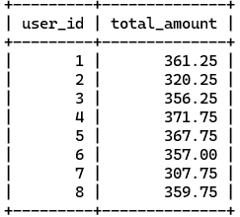

# Group By Clause:

# Get the count of orders for each restaurant:

SELECT restaurant_id, COUNT(*) AS order_count

FROM Orders

GROUP BY restaurant_id;

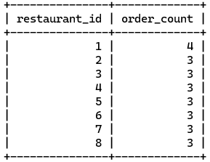

# Where Clause:

# Get the details of the driver with the name 'Rohit Sharma':

SELECT * FROM Drivers WHERE name = 'Rohit Sharma';



# Arithmetic Operators:

# Get the total price of all menu items for a restaurant with ID 1:

SELECT SUM(price) AS total_price FROM Menu WHERE restaurant_id = 1;

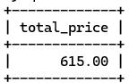

# Comparison Operators:

# Get users who have placed orders with a total greater than $50:

SELECT DISTINCT user_id FROM Orders WHERE order_total > 50;



# Logical Operators:

# Get orders with a delivery status of 'Cancel' or 'on the way':

SELECT * FROM Orders WHERE delivery_status = 'cancel' OR delivery_status = 'on the way';

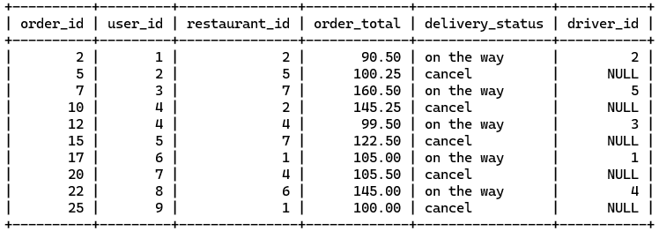

# Null Value:

# Get users who do not have an associated address:

SELECT * FROM Users WHERE user_id IN (SELECT DISTINCT user_id FROM Address)

limit 5;

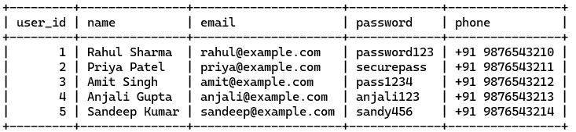

# Limit Command:

# Get the first 10 orders:

SELECT * FROM Orders LIMIT 10;

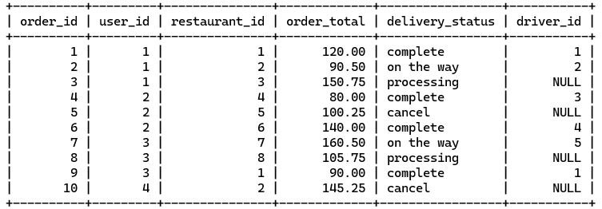

# Single Row Subqueries:

# Get the email of the user who placed the highest order:

SELECT email FROM Users WHERE user_id = (SELECT user_id FROM Orders ORDER BY order_total DESC LIMIT 1);



# Multiple Row Subqueries:

# Get users who have placed orders at restaurants in 'Thane':

SELECT DISTINCT user_id FROM Orders WHERE restaurant_id IN (SELECT restaurant_id

FROM Restaurants WHERE address = '123, ABC Road, Thane');



# Subquery with IN:

# Get the names of restaurants where the average order total is greater than $50:

SELECT name FROM Restaurants WHERE restaurant_id IN (SELECT restaurant_id

FROM Orders GROUP BY restaurant_id HAVING AVG(order_total) > 50);

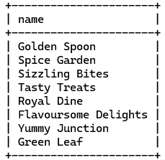

# Subquery with ALL:

# Get users who have placed orders with a total greater than all orders placed by user with ID 1:

SELECT DISTINCT user_id FROM Orders WHERE order_total > ALL (SELECT order_total

FROM Orders WHERE user_id = 1);

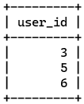

# like Operator

SELECT * FROM Users WHERE name LIKE 'A%';

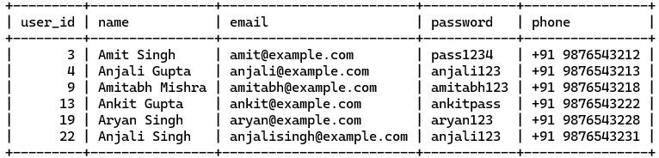

SELECT * FROM Users WHERE name LIKE '%A';

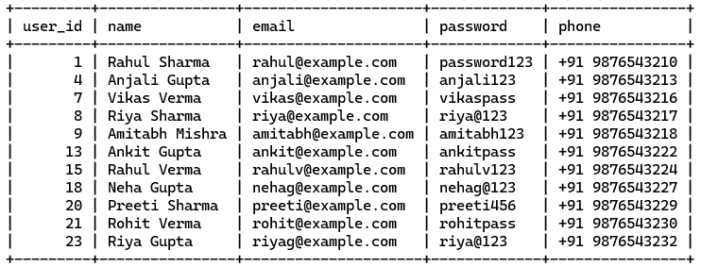

SELECT * FROM Users WHERE name LIKE '_R%';

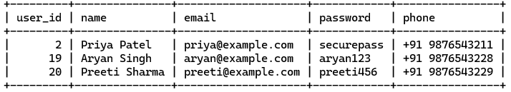

SELECT * FROM Users WHERE name LIKE 'R_%';

